**Name:**

**Java Programming**

**Lab Exercise 12/5/2024**

**Bingo Card Generator**

In this exercise, you will create a BingoCard class. The rules for what the card is made up of are as follows:

The most common Bingo cards are flat pieces of cardboard or disposable paper which contain 25 squares arranged in five vertical columns and five horizontal rows. Each space in the grid contains a number.

A typical Bingo game utilizes the numbers 1 through 75. The five columns of the card are labeled 'B', 'I', 'N', 'G', and 'O' from left to right. The center space is usually marked "Free" or "Free Space", and is considered automatically filled. The range of printed numbers that can appear on the card is normally restricted by column, with the 'B' column only containing numbers between 1 and 15 inclusive, the 'I' column containing only 16 through 30, 'N' containing 31 through 45, 'G' containing 46 through 60, and 'O' containing 61 through 75.

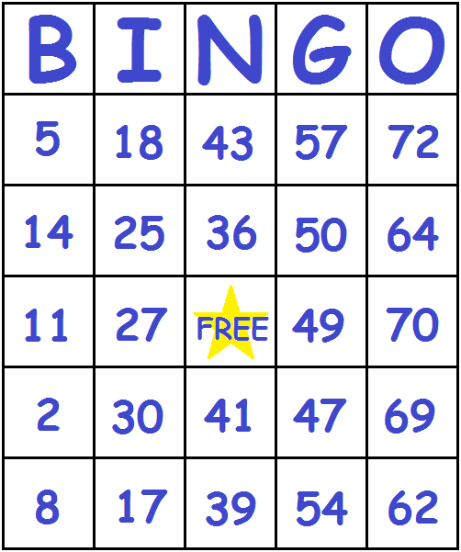

Your BingoCard class should have the following:

1. A data structure for storing the card
2. A constructor to create the card (use some sort of randomization)
3. A method to print the Bingo card to the screen
4. A method to update the card as to which spaces have been filled
5. A method to determine if a player has won. A win involves having a column, row, or diagonal filled.

Write a Driver class to test all of the features of the BingoCard class.